**STB AutoIngest**

Story : TL-541-STB Auto Ingest

Refer below document :



**QA:**

Teams link : https://web.microsoftstream.com/video/a193308d-5e9c-4630-8523-52a2e43d7ca0

Testcase sheet: https://docs.google.com/spreadsheets/d/1HYryDMRsbiVtwznB0Tex4dMO6kQo17nnFfwqSY6WFuk/edit#gid=0

In MC 134 , Processor installed path C:\Clear\PROCESSORS\PFT_STBAutoIngest

Logger.log is available in above path

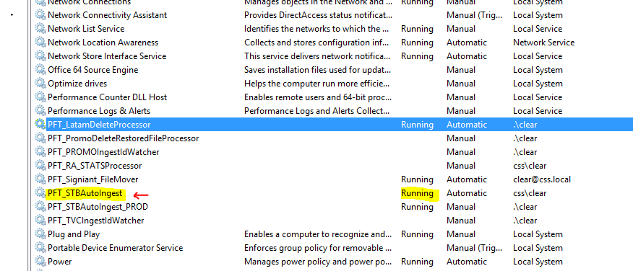

Drop excel in below source path for QA Env,

SOURCE PATH - \\10.161.239.229\contentdelivery\Clear_QA_STB_ING_Outgoing

DESTINATION PATH - \\bim-disk-t\clear\Longform_QA\Clear_QA_STB_ING_Incoming

* There are two folders ‘Processed’ & ‘Failed’

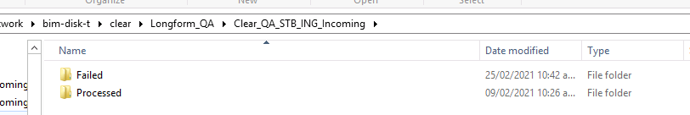

**Production :**

In MC 134 , C:\Clear\Tools\PFT_STBAutoIngest_PROD

SOURCE PATH - \\10.161.239.229\contentdelivery\Clear_Prod_STB_ING_Outgoing

DESTINATION PATH - \\bim-disk-t\clear\Longform_Prod\Clear_Prod_STB_ING_Incoming

* Excel should be prepared with below mentioned columns,



* Drop the Excel file in below path : (Filename can be any name )

\\10.161.239.229\contentdelivery\Clear_QA_STB_ING_Outgoing

* The Excel file moves to below MC destination through Signiant and gets Processed

\\bim-disk-t\clear\Longform_QA\Clear_QA_STB_ING_Incoming

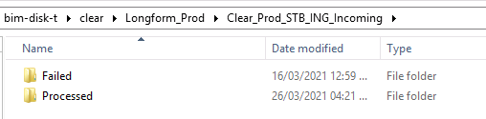

* Incase of Invalid Data , excel will be moved from MC (Failed folder) to below path in Corp :

O:\Clear_PROD_STB_ING_Incoming\Failed

* If all the data is correct & Processed , excel will moved to ‘‘Processed’’ folder

Note :Excel will be appended with date & timestamp.

* Notification for below invalid data will be triggered to Media management Team:

Duplicate segment number, Duplicate segment filename, Duplicate segment location

* Incase of duplicate segment number, filename , location, status will be set as Invalid Data,

excel will be moved from MC (Failed folder) to below path in Corp :  
O:\Clear_PROD_STB_ING_Incoming\Failed

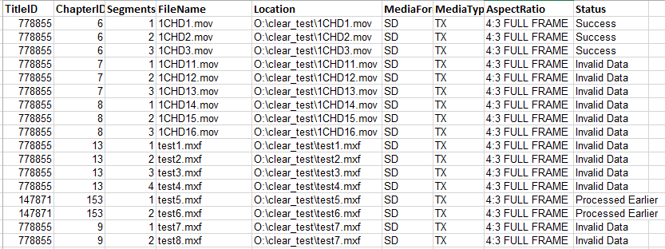

Sample Notification:

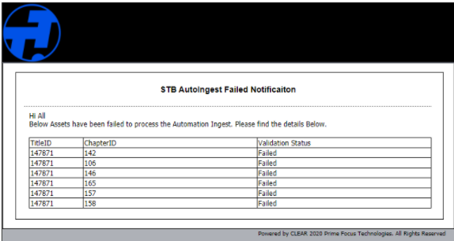

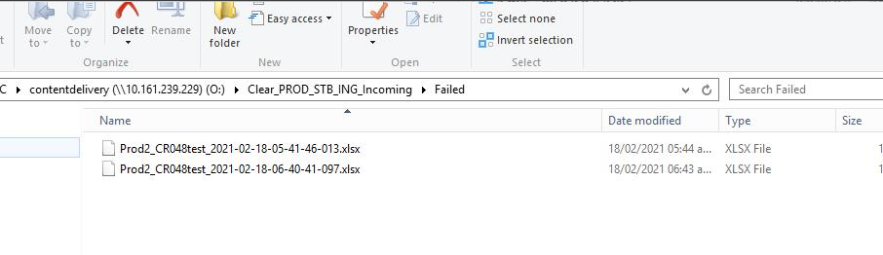

* EditWO , Notify & Start WF will be done automatically.
* Navigate to Latam Dashboard& check the EditWO and WF status .

Note: STB AutoIngest will not be applicable for restarted WO.

**Poster Migration :**

Testcase sheet: https://docs.google.com/spreadsheets/d/1r7WQs7GPkmrLTQTfeKrFm1QNDBcMwH74iVZXWchK8Tg/edit#gid=1193379185

The posters will be migrated and uploaded as Essence at Title and Chapter folder level as applicable. CLEAR need to take all the posters from below location and register as an essence of the Title if Chapter information is not available or register as an Essence of the Chapter if the Chapter information is available in the database for that poster.

The posters are currently stored in the below storage location

\\bim-disk-t\vod\VODImagenes\

Filename for the Poster will be as below material_chapter_title_widthxheight_imageType_language

material = aleph material. Always it has a value.

chapter = aleph chapter. It could be 'x' if it isn`t defined.

title = aleph title. It is variable. It could have severals '_'

width = it is the width of the image. The service checks the width of the image.

height = it is the height of the image. The service checks the height of the image.

imageType = it is the type of the image. It is defined in the db in table VOD_image_format

language = It could be 'x' if it is the same images to all languages. It is defined in the db in the table VOD_Language

Tables:

select * from TURNERTRACKERQA.Longform.PosterJobs

select * from TURNERTRACKERQA.mediaarchive.Dam_TURNERTRACKERQAImagesExtn

select * from [TURNERTRACKERQA].[Longform].[PosterMigration_Images]

select * from [TURNERTRACKERQA].[Longform].[PosterMigration_ImagesFormat]

select * from [TURNERTRACKERQA].[Longform].[PosterMigration_ImagesType]

* Data from excel will be loaded into PosterJobs table and will be processed once completed check the status in DB

Testcase Link : <https://docs.google.com/spreadsheets/d/1r7WQs7GPkmrLTQTfeKrFm1QNDBcMwH74iVZXWchK8Tg/edit#gid=1193379185>

* Set up the console Application in UAT Environment in 223 server Application (L:\PosterMigration) : GetFolderDetails_Turner_Migration.exe
* Configuration : GetFolderDetails_Turner_Migration.exe.config

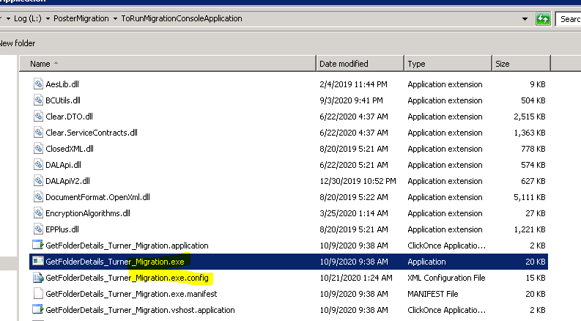

* Using console application , load the data( Images ,format ,Type & Extension) into temp table that is [Longform].[PosterJobs] ( onetime activity)
* In the Config , provide the source path and excel Filename to load data into DB.

<add key="sourcePath" value="L:\PosterMigration" />

<add key="fileName" value="vod_images.xlsx" />

* Once after data is loaded into PosterJobs Table status should be in 'New'
* Setting up of Service to Migrate the posters :Installed in 223 server , in services "PFT.Turner.LegacyProcessor.PosterMigration"

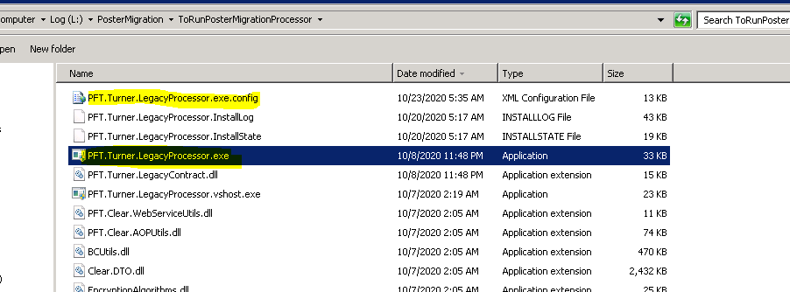

1.Start the Processor PFT.Clear.Turner.LegacyProcessor.PosterMigration

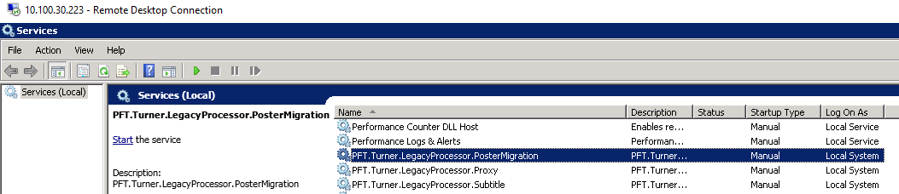

2.Processor has to pick up the data from DB (PostersJob) Table which is in "NEW" status

3.Once Migration is in Progress, status to be changed to "INPROGRESS"

4.After completion status to be changed to "COMPLETED"

5.WF will be triggered , LFPoster_Migration and poster will be registered as an Essence & available in Asset Library under Title-Chapter folder.

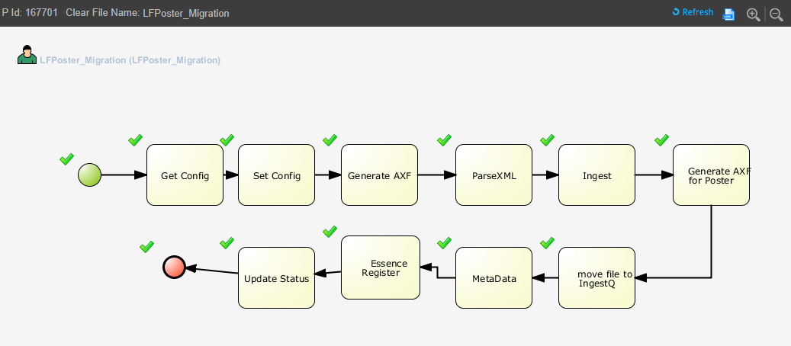

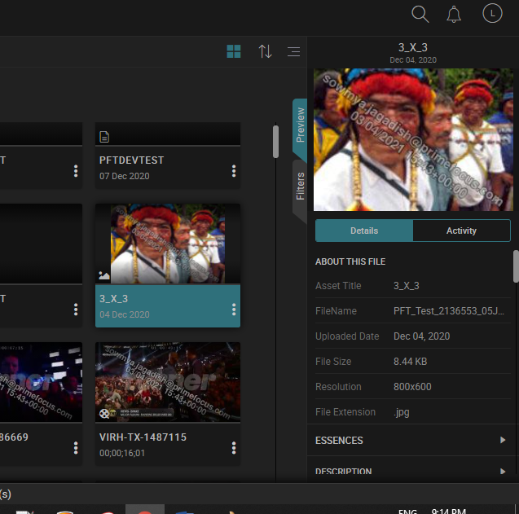

**Due date**

Story: TL-4471-Due date calculation

Testcase sheet:https://docs.google.com/spreadsheets/d/178FN2-JP_ou3nyON-kSbG0BFt-ZNwErfQZ2dhvnFFTk/edit#gid=0

* Due date is calculated when Start flow is completed.
* There is no separate due date for Rating , breakstructure or any review tasks.
* There is no due date logic for missing subtitle , missing rating ,QC only flows.

|  |  |  |  |
| --- | --- | --- | --- |
|  | Tasks | MAX days | MIN days |
| 1 | QC | 5 | 1 |
| 2 | ED | 5 | 2 |
| 3 | SUB | 9 | 1 |
| 4 | DUBB | 50 | 25 |
| 5 | S&P | 7 | 2 |

**Subtitle Retimecoding :**



**Link:**

<https://confluence.primefocus.com/display/EN/Subtitle+Conversion%2CRe-timing+-+Design>

https://web.microsoftstream.com/video/8cf72567-b50c-43d3-8727-99c61e521cea

Teams link :

<https://web.microsoftstream.com/video/45875a90-7d56-483b-91b8-23f1671384e9>

Product Demo : https://web.microsoftstream.com/video/7da5b9b6-3fa6-4966-8676-7ff3b674f32f

* subtitle retimecoding MC IP : 10.100.30.143
* When EDL file is given in PE EditWO and EditedCopymaster , subtitle retimecoding will be triggered.
* EDL file name can be any filename and should be available in EditorOutput
* Edl File should contain Ingestids and validation should display if invalid ingest Id is given &when file not available in EditorOutput location.
* Testcase : <https://docs.google.com/spreadsheets/d/1M1pFmDu3AeGiS5_1L_2hoN7KOoqGq5wfxAtSUTD1Zaw/edit#gid=138582230>
* Note : Black Video in EDL will be supported , ‘NONE ’ in the edl file will not be supported.
* If no EDL is given in Edition task , then manual subtitle task will be created.
* EDL Format used is CMX-3600.
* Edl contains V(Video) , A(Audio), AA(Audio on channel1 and channel2)
* Compare Source file STL, retimecoded STL , EDL for retiming and check whether subtitle in sync.
* Example:

001 AX V C 01:00:00:04 01:02:40:01 01:00:00:00 01:02:39:27

* FROM CLIP NAME: B68SJ_MT.mov

01:00:00:04 🡪 timecode for the Source In point (Clip In)

01:02:40:01 🡪 timecode for the Source Out point (Clip Out)

01:00:00:00 🡪timecode for the Master / Recorder  In point

01:02:39:27 🡪timecode for the Master / Recorder Out point (=Clip Out - ClipIn + Recorder In point)

Below is the Edl shared by customer for Assets in 1 and 7 folder.

\\bim-disk-t\clear\SampleFiles\LongForm\Subtitle EP01_noaudio.edl & EP07_noaudio.edl

Source master : O:\clear_test\TESTDATA_DONOTDELETE\Subtitle_Retime

* Testadata location : \\bim-disk-t\clear\SampleFiles\LongForm\Subtitle (Use the Assets from this location but Use the above EDLs for testing ), new Testdata is requested for Customer. Refer below JIRA .
* Refer Jira for existing issue : <https://jira.primefocus.com/browse/TL-5398>
* TL_STL_RETIMECODE_REQ is the new column added in WOExtn table
* If subtitle upload is manual task then it is done by internal user.

Refer the below steps to understand the process & file movement.

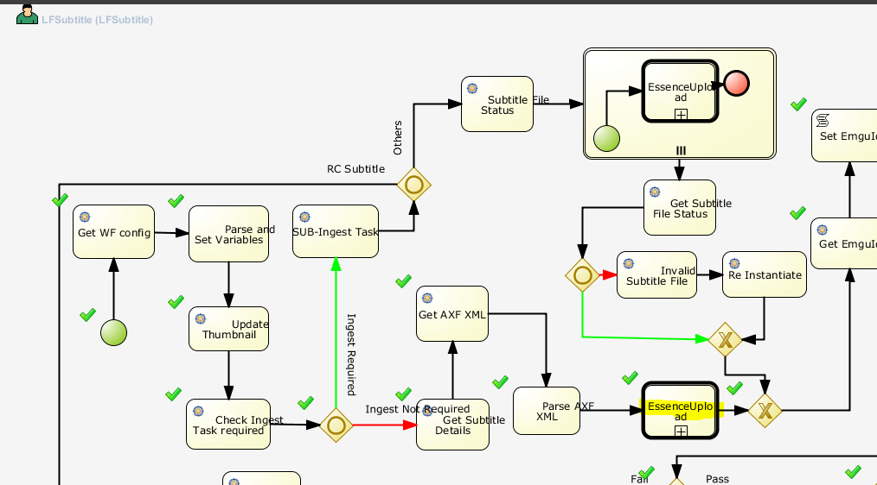

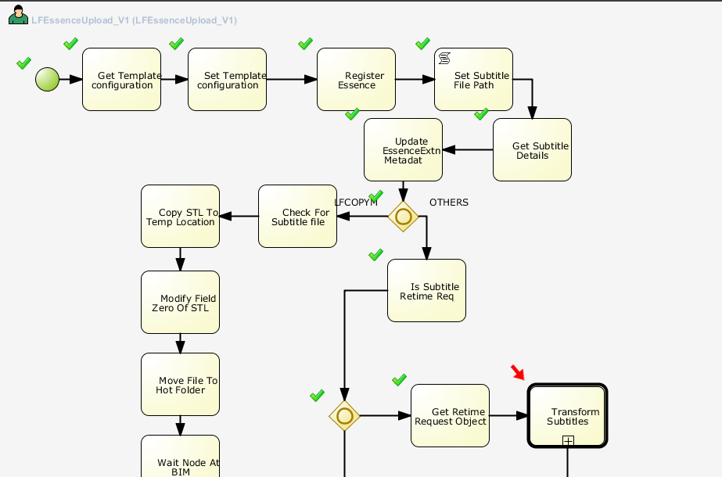

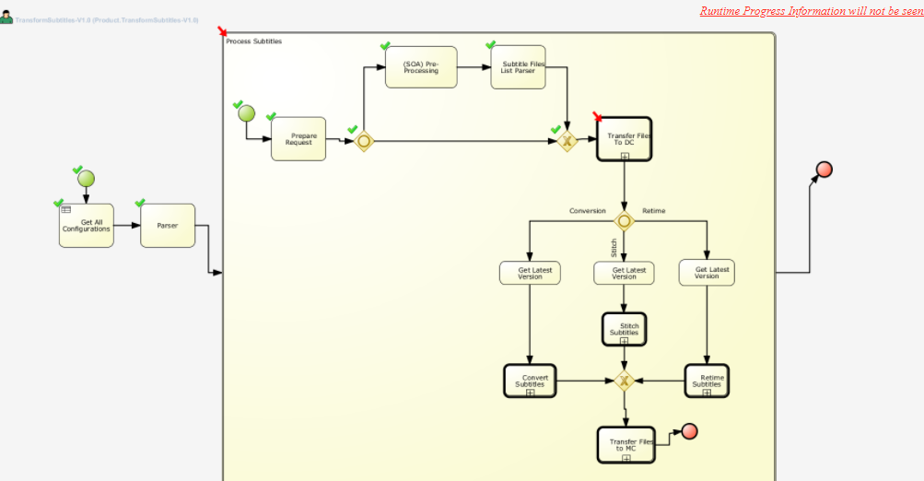

Below is for LFFileCopyFromCORPToBLAN:

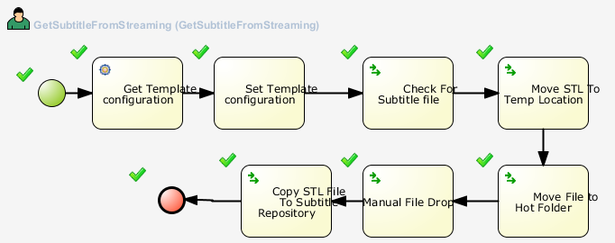

* STL uploaded on Source master will be copied from streaming location and copied to MC (folder name : SubtitleRetimeSFTPInput)

**Move file to service location :**

SourcePath=//bim-disk-t/clear/Longform_QA/Subtitle/SubtitleRetimeSFTPInput

DestPath=\\10.185.134.134\Clear\webservices\PFT.Clear.LatamSubtitlesFiles

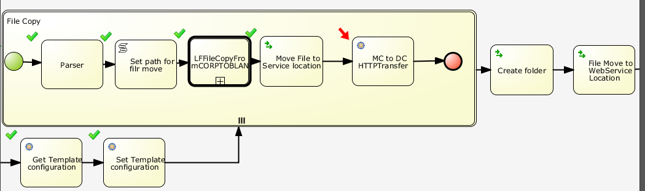

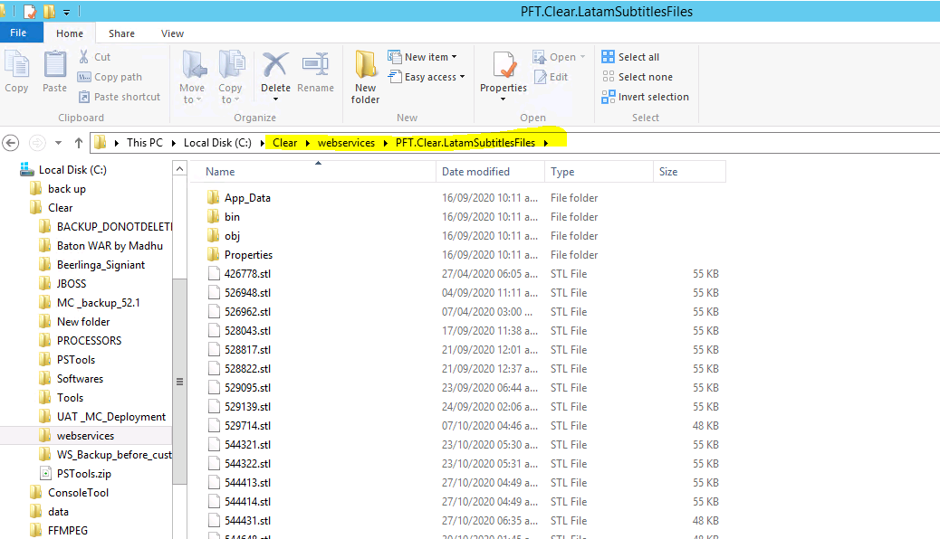

**MC to DC HTTPTransfer:** Using the below service , file will be transferred from MC to 143 server below is the path.

srcFilePath:http://10.185.134.134:1005/PFT.Clear.LatamSubtitlesFiles

DestFileName=554074.stl

DestPath=\\10.100.30.143\DCSharePath

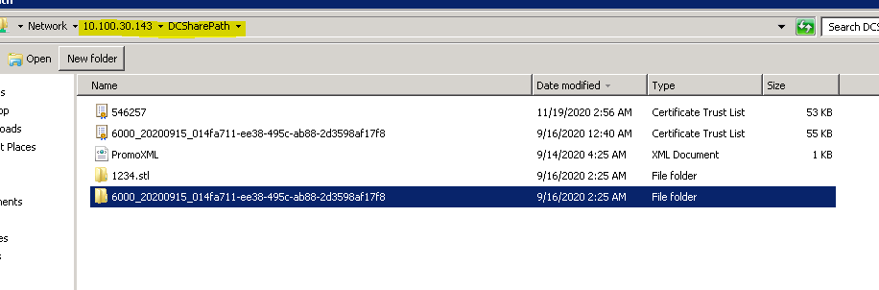

**Create folder** :Folder will be created in below path

SourcePath=\\10.100.30.143\ServiceSharedPath

SrcFileName=6000_20201101_91637cef-3bc5-4f64-a949-e1a369dec848

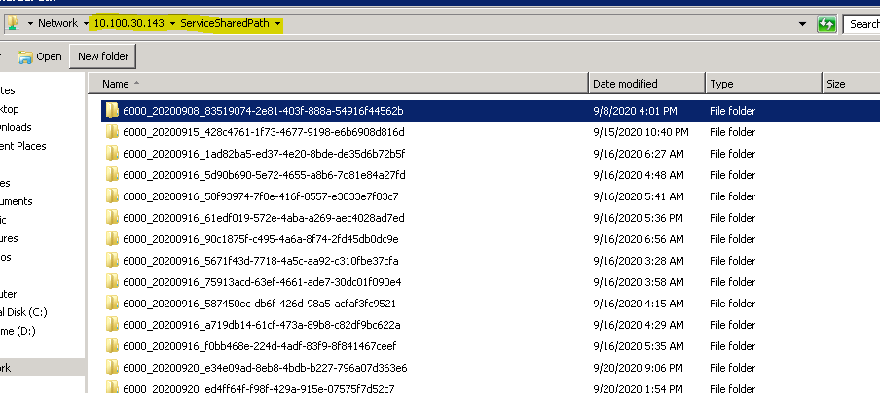

**File Move to WebService Location**

SourcePath=\\10.100.30.143\DCSharePath , SrcFileName=544648.stl

DestPath=\\10.100.30.143\ServiceSharedPath\6000_20201101_91637cef-3bc5-4f64-a949-e1a369dec848

DestFileName=544648.stl

* Subtitle Retimecoding will be done using EZconvert Tool (is a subtitle conversion tool) present in 143 server.Below is the highlighted Ezconvert tool, STL & edl will be submitted to this tool using the command (product service : PFT.Clear.EzConvertUtils)
* https://confluence.primefocus.com/display/EN/Transform+Subtitles+SOP

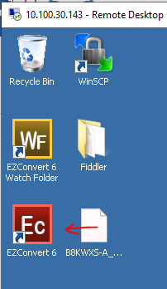

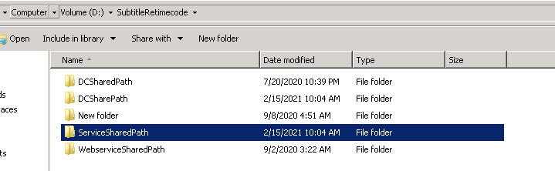

**Note** : In case of any node stuck , login to 143 MYSQL server and check the wf status and LOGS (similar to 134 MYSQL)

**Manager & Agent path in 143 server :**

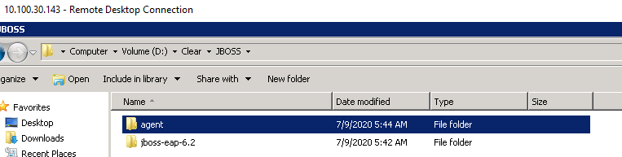

Paths in below sheet:

<https://docs.google.com/spreadsheets/d/1fMF0NT3anGuhuSC9uXrdvC1LAEZwuLu5-gYWm2yzo0s/edit#gid=678877564>

* After retimecoding , check the playlist in asset library and play the video to check the subtitle is insync with the video.

STL will be registered as essence against playlist.

* Similarly check for the edited copymaster in libray for the subtitle sync & STL will be registered as essence against edited copymaster .
* Check the STL DB integration and Aleph.
* Retimecoded STL will be sent to streaming location.

Below are the calls for Reference :

<http://10.100.30.223:1005/PFT.Clear.Utility/UtilityService.svc/webhttp/json/PrepareTTTRetimeRequestObject>

Ex: pass the below body

{

"EditListPath": "",

"EditList": "",

"EditListType": "EDL",

"SubtitleLanguage": "BRA PORTUGUES",

"OutputFormat": "STL",

"TimecodeFormat": "DF",

"SOM": "01:00:00;00",

"FrameRate": "29.970",

"OutputFileName": "FIBHTX33078--20201105000400541223--544--PL--6000PORT",

"OutputPath": "D:\\Subtitle"

}

2. http://clearwscluster:1005/PFT.Clear.MAM.MediaObjectManagemnt/api/V1/Assets/GetDerivedTimedTextTrack

{  
  
"clearID": "TITLEFORQATEAM01Chapter06--20201104064356332223--548--LF--6000"  
  
}

3. <http://clearwscluster:1005/PFT.Clear.Utility/TimedTextTrack.svc/webhttp/SubtitleConvert>

Body:

{

"SourceFileName": "FIBHTX12583--20201101062050464223--544--PL--6000_1_imsc.xml",

"SourceFormat": "IMSC",

"OutputFormat": "STL",

"OutputFolderName": "6000_20201101_627aae8d-154f-48a4-b53f-995f74624c59",

"SourceFrameRate": "29.970",

"SourceSom": "01:00:00;00",

"SourceTimeCodeDisplayFormat": "DF",

"OutputFileName": "FIBHTX12583--20201101062050464223--544--PL--6000_1_STL"

}

Use below tool ‘Subtitle Edit ’ Tool to view .stl Files, download from below link:



https://subtitle-edit.en.softonic.com/

**Restore playlist using Story teller:**

Navigate to Asset Library ,

1.Create playlist using storyteller, add the assets to bin and open from story teller.

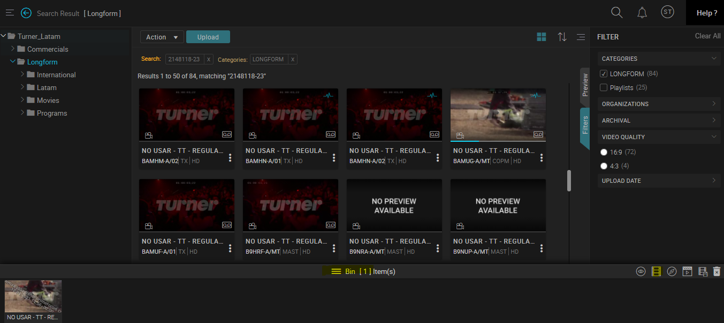

2.Create segments by mark in & mark out .Click on save , choose the folder & provide filename.

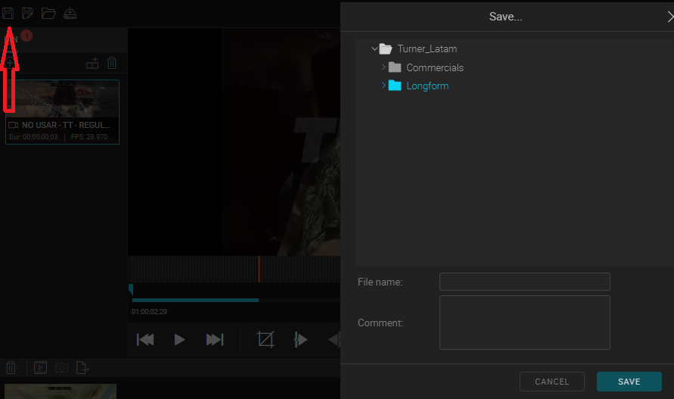

Follow the steps attached in the document to load the playlist created in step1.



3.To restore click on Restore icon and provide Title, select Workflow (any of the below highlighted) , priority and submit.

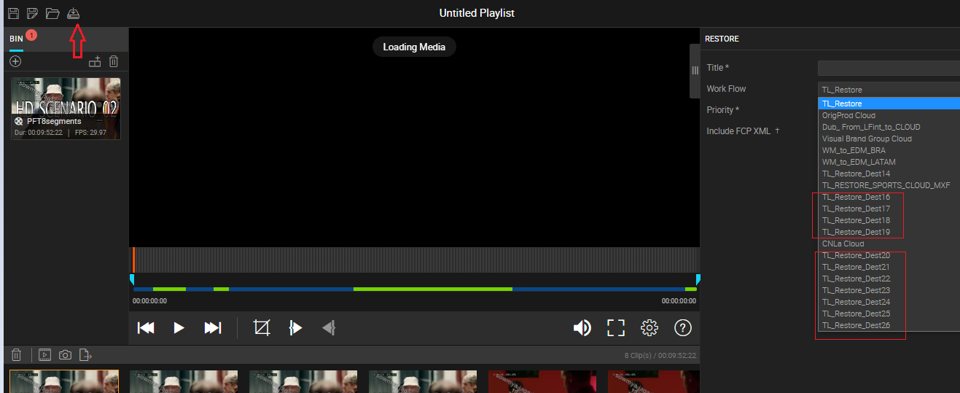

4.WF will be triggered in smart tasker , check the restored file in below location (check in the destination folder as given while restoring in the Workflow drop down –refer above screenshot)

\\bim-disk-t\clear\clear_staging

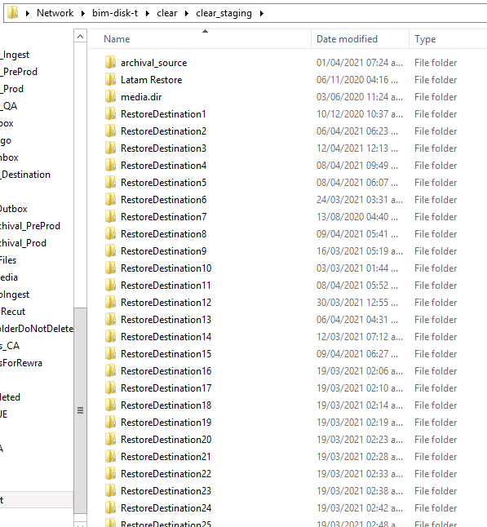

To edit the playlist using Editor:

1.Open the playlist in editor

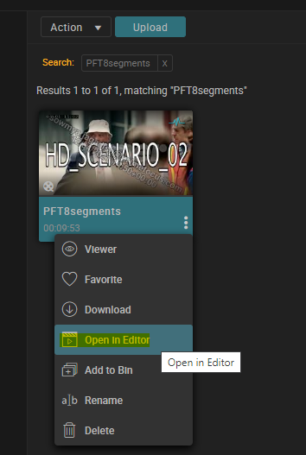

2.Edit the segment details and the TC in /out

3.Click on save

4.Now open the playlist from story teller by adding it to bin and click on 'open from storyteller'

5.click on "Add to playlist" to check the segment's name  are same as given in editor

For Customer Feedback & issue existing for storyteller : **https://jira.primefocus.com/browse/ULD-1867**